Check TQA

# Purpose

The therapists perform Total Quality Assurance (TQA) tests on Tomo as part of their daily QA before the day’s treatments. TQA results are recorded in the TQA software, which is locally hosted at CRMC. This procedure describes how to check daily TQA results to ensure that it is safe to treat patients on Tomo that day.

# Steps

1. Log into TQA.
   1. You should have a Desktop shortcut to the TQA website. If you do, simply double-click the shortcut to open TQA.

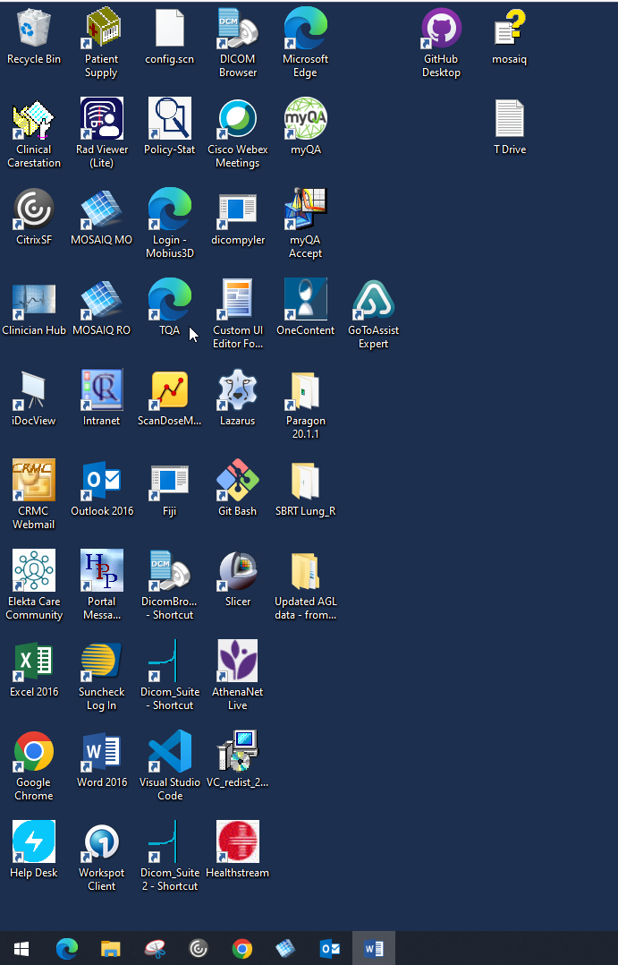

**Double-click the TQA shortcut to open TQA**

If you do not have a Desktop shortcut, you should create one. Until then, type the TQA URL into the browser URL bar, just as you would visit any other website. The TQA URL is in the [TQA link](../../../../QA%20&%20Procedures/Tomo/TQA/TQA%20link.txt) document at T:\Physics\QA & Procedures\Tomo\TQA.

**TQA URL:**

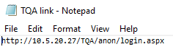

**Go to TQA website:**

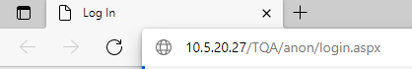

The screenshot shows Microsoft Edge, but use whatever browser (e.g., Chrome) that you wish.

* 1. Enter your credentials. These are not your CRMC domain credentials (the credentials you use to log in to a CRMC computer).

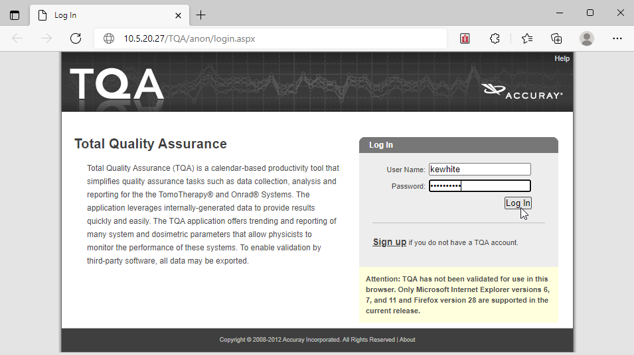

If you do not have a TQA account, you should click Sign up to create one.

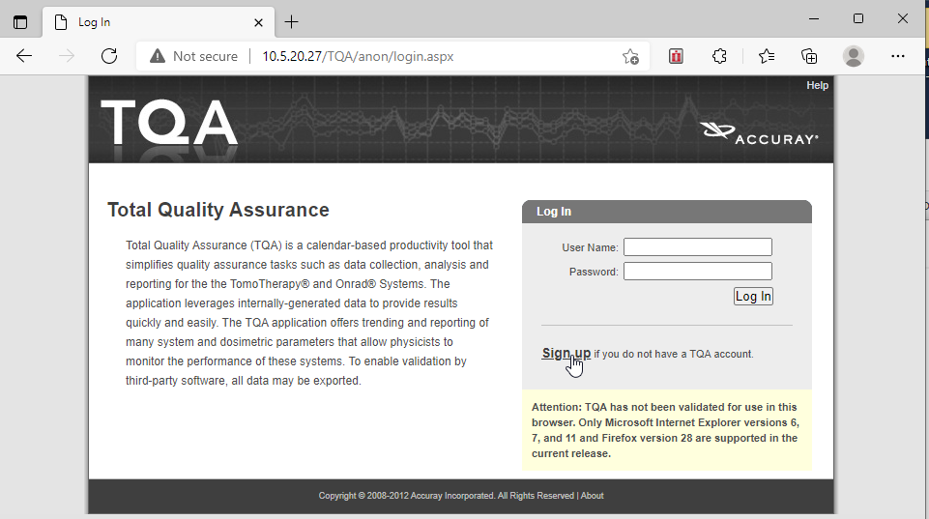

Until you have an account, you may use the therapists’ TQA account with username *therapist* and password *therapist1_*.

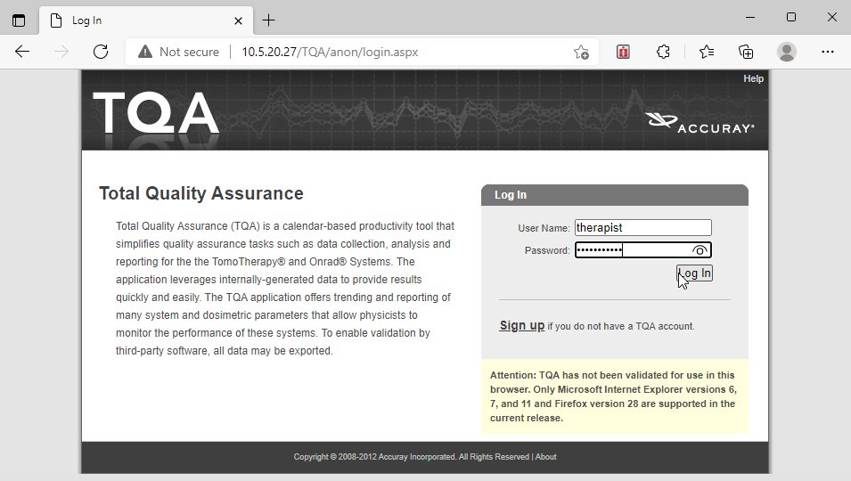

1. Check today’s TQA tests. You may need to click the *More details* link to see all of today’s tests. The therapists have a schedule of tests; different tests are performed on different days.

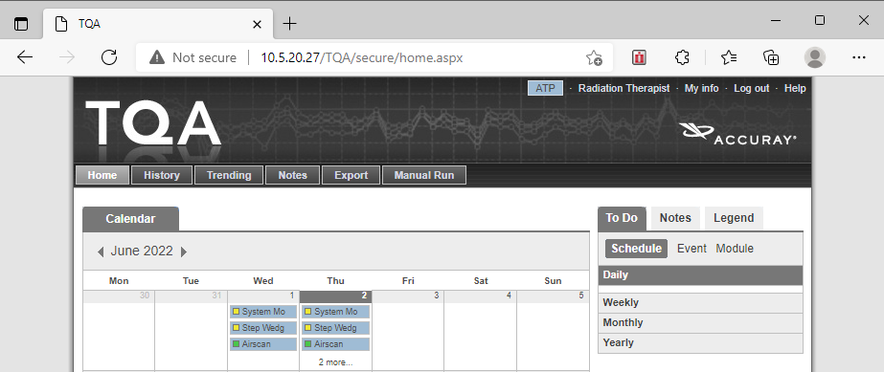

**TQA tests performed on June 2**

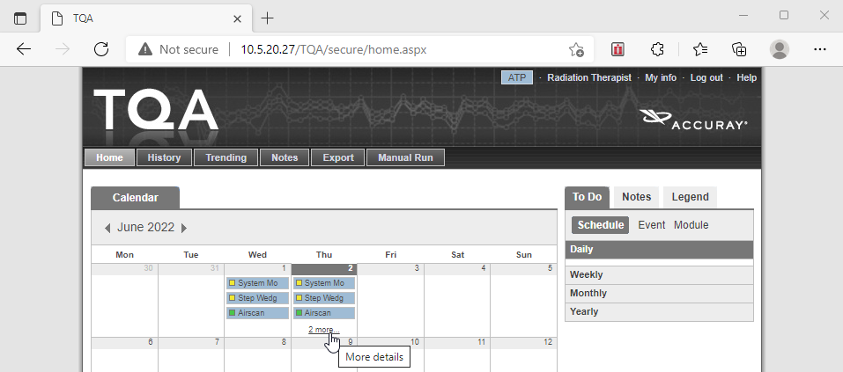

**Click to see the rest of the test list**

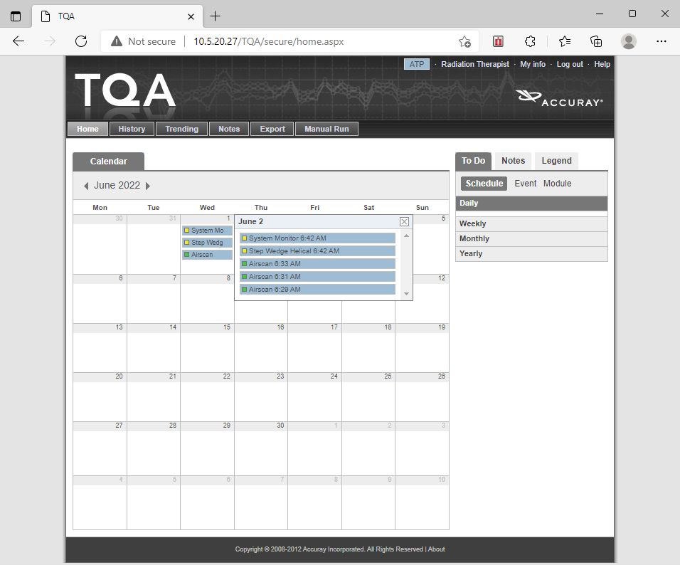

**All TQA tests performed on June 2**

Check the following:

1. TQA was performed today. If there are no tests for today, therapy should have informed a physicist. This likely means that Tomo is down.
2. All results are yellow or green. Green indicates a pass, yellow a warning. All TQA tests are very sensitive, so a yellow result is usually okay. Therapy is supposed to check their TQA results every day and inform a physicist if anything is red, but this doesn’t usually happen. To see more details on a TQA result, click it.

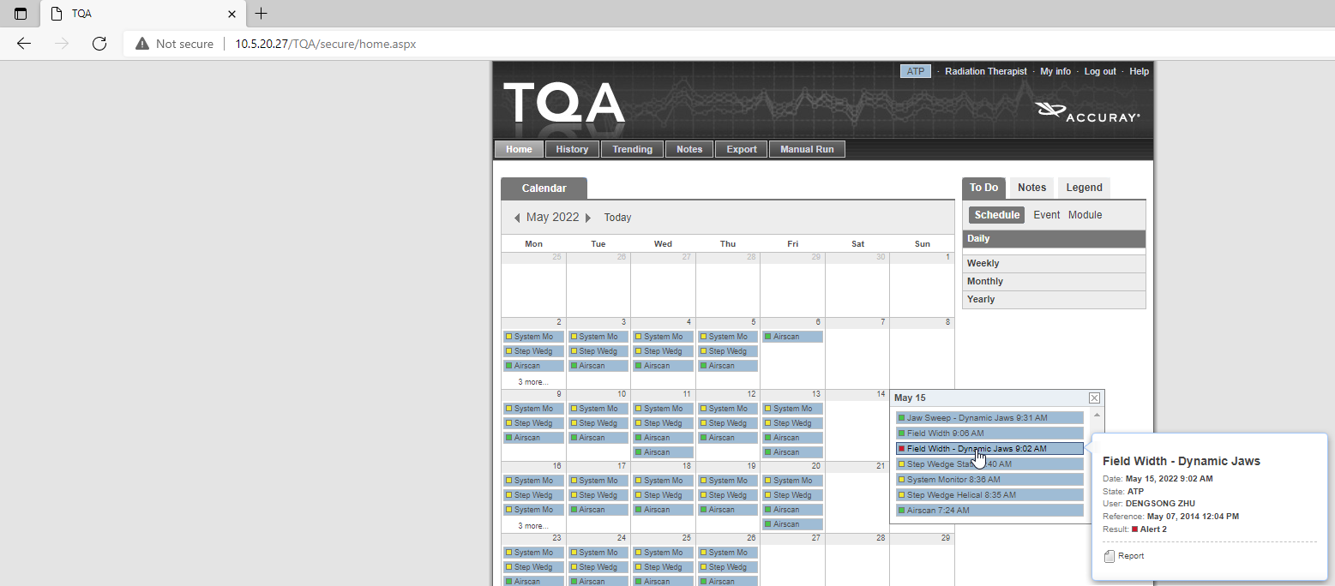

**Click the result to see more details**

Then click the *View report* link to see all details.

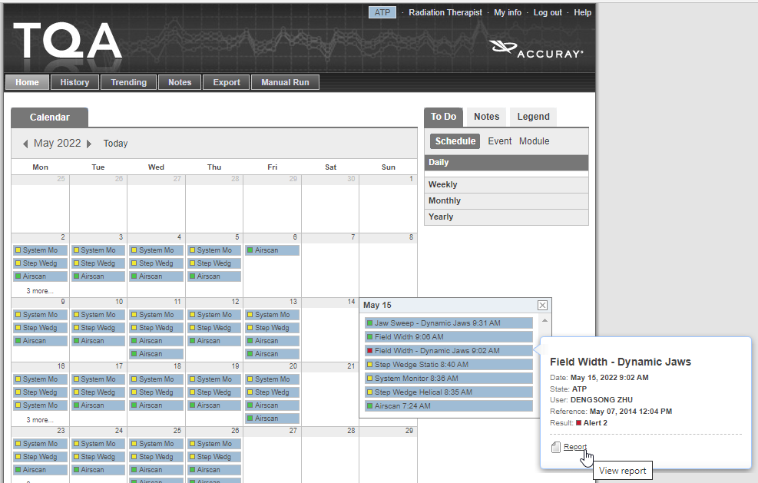

All details on the test:

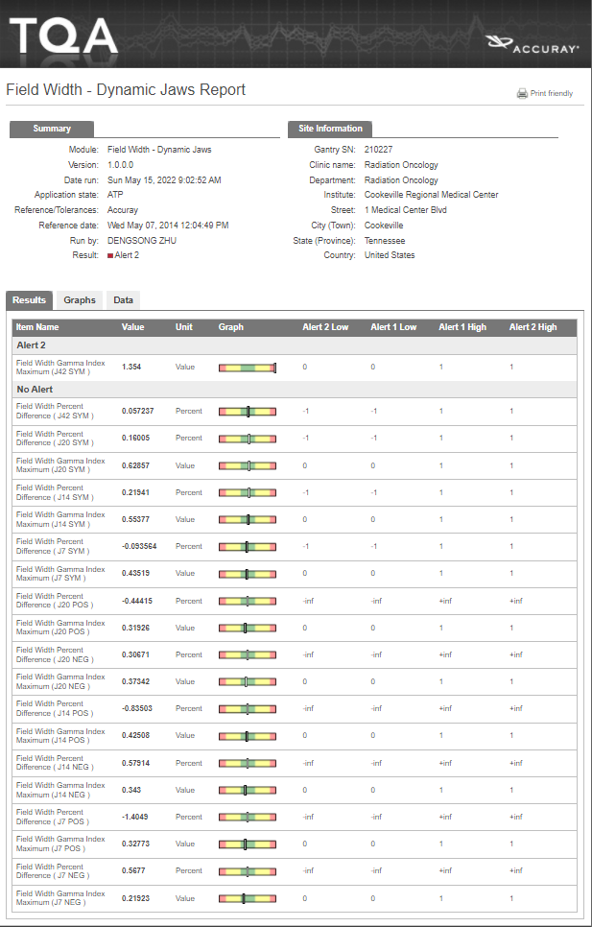

1. No test was performed twice. In the below screenshot, Airscan was performed twice even though it passed the first time.



**Airscan was run at 6:31 and 6:33 even though it passed the first time, at 6:29**

This usually happens because a second therapist runs the test when they don’t realize that someone else already did. The therapist that did TQA is supposed to add a Note with their initials (see procedure [Add a Daily TQA Note with Your Initials](Add%20a%20Daily%20TQA%20Note%20with%20Your%20Initials.docx) at T:\Physics\QA & Procedures\Tomo\TQA) so that (a) other therapists know that TQA has been performed today, and (b) if there is a problem, physicists know which therapist to consult.

1. If there are any problems, consult the therapist who performed the questionable tests. First check for a Note for today’s date.

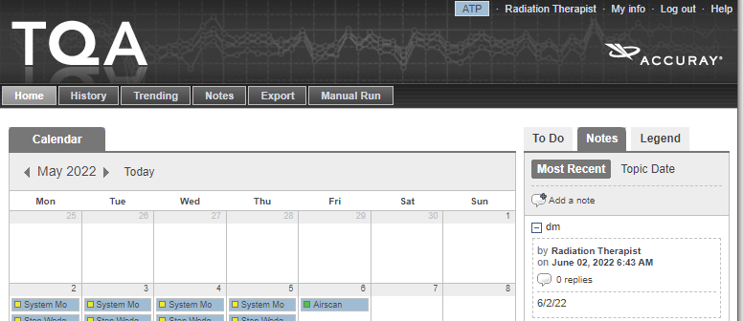

**DM (Dave Maynard) shot TQA on 6/2/22**

If no one left a Note with their initials, consult the therapists who are scheduled on Tomo today.